Project team can follow the below steps for creating multiple NonSSO users

- Please raise a ticket and ask the DevOps team to create a nonsso org and non sso DNS url if not present in the requested environment.

Please note non-sso url should be end with -2 , Please don't use test or something
Example nonsso url > https://danonepreprod-2.o9solutions.com/kibo2

- Download users from the tenants workspace

3. edit the Excel sheet and append the new users. Add the fields "Id,Name,Email,UserRoles" These fields are mandatory . Please note adding users into any tenants through excel sheet is project team/CS team job , If you are not aware please discuss internally within your team .

User format should be XXXX@testing.com … example concurrent1@testing.com and so on ..

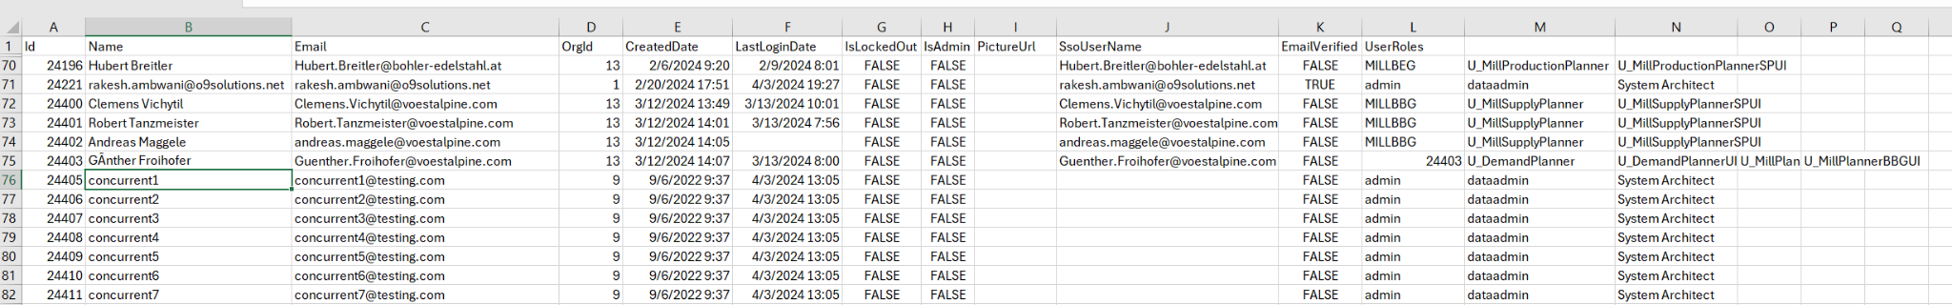
NOTE: email id of non-sso user shouldn’t end with o9solutions.com
NOTE: Do not remove any users already present in the excel sheet .

4. After adding the users, upload the excel sheet to tenant "Upload users".

Once this is successful, the users will get created under the o9 solutions organization.

5. In the same ticket ask DevOps Team to change the Organization of the users to NON-SSO org.
Devops Will change the OrgID of the users to NON-SSO org and will close the ticket.
update Users set OrgId=<nonssoorgid> where Email like '%@testing.com'

select * from Users where Email like '%testing.com'

Also please make sure , You make all users into service account otherwise they will get MFA
(ask devOps team to do it from SQL)

6. Post changing the orgid the password of the non-sso users needs to be reset manually from the kibo>>tenant>>users. This can be done by the project team .

Log in to the kibo url:
https://<cusomername>.o9solutions.com/kibo2#/

1. Goto tenant workspace
2. expand the requested tenants
3. Under the users, Filter with the username "concurrent"
4. Click on the password cell of the non-sso user and add the new temporary password Ex: "Test@12345" (This is a temporary password which will get expired once you login)

5. Click on Save changes.
6. Open the non-SSO URL 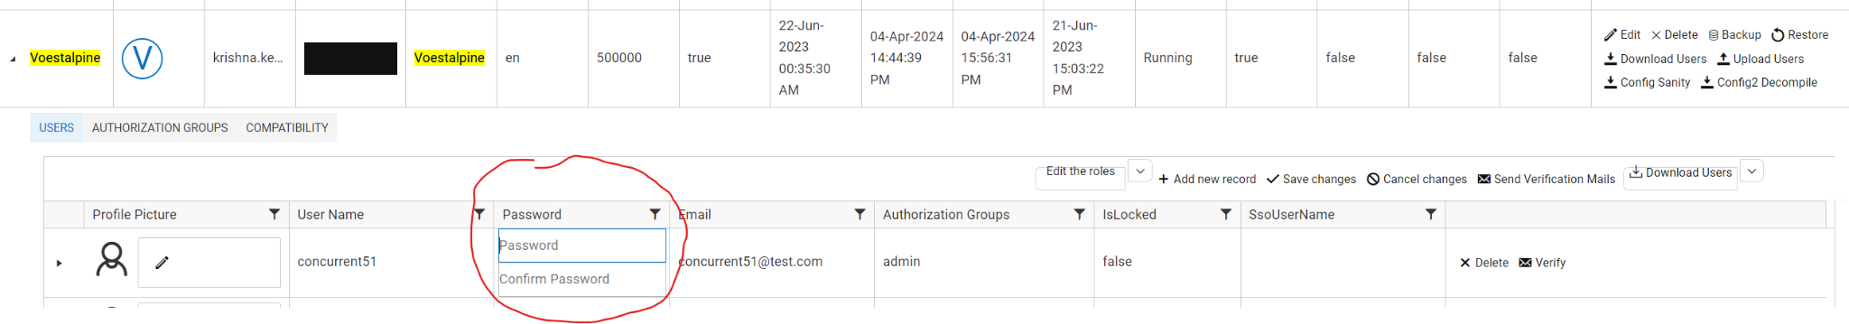
7. Give the current username and the temporary password. It will ask you to reset to the new password.
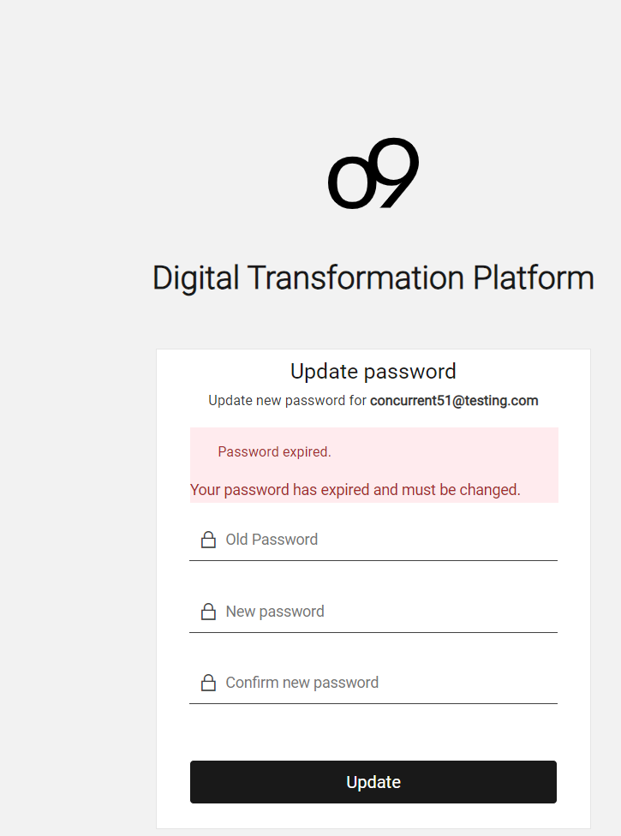
8. Project Team can give the actual password on that page to reset it.
9. Project Team will have to follow these complete steps for the remaining users.

Please note - the regression testing user should be restricted to use within our o9 network ( ZTNA). They should not be allowed to use outside of o9 network as its not a named user

